August 5, 2021
4-5:00 PM EST
RHO Implementation Monthly Investigator Call Minutes
Invitees/Attendees:
Dr. Larry Rhein, Principal Investigator |  | Boston Children’s Hospital |  | Maria Fareri Children’s Hospital
Heather White, Project Coordinator |  | Children’s Hospital of Philadelphia |  | Massachusetts General Hospital
Lindsey Simoncini, Research Assistant |  | Cincinnati Children’s Hospital |  | Nationwide Children’s Hospital
Maria Matoshi, Research Assistant |  | National Jewish Health, Colorado |  | Peyton Manning Children’s Hospital
Arkansas Children’s Hospital |  | Dartmouth-Hitchcock Medical Center |  | U. of California, San Diego
U. of Kentucky Children’s Hospital |  | University of Maryland |  | Vanderbilt

Site Trainings
- All Wave 1 site trainings have been completed.
- 6 out of 8 Wave 2 site trainings have been scheduled.
- We now have home cares at each implementation site supplying RAD 97’s.
  - Heather is working on obtaining a list of total devices at each of your home cares.
IRB/regulatory
- SMART IRB for Wave 2 sites is now open!
- Let Heather know if you have any questions.
- Please notify Heather once you submit your REDCap access request form.
- Please send your current list of study personnel and CITI certificates to Maria Matoshi as part of the regulatory documents’ requirement.
- Refer to Site Progress table on Page 4.
Site progress on Implementation Start-Up
- A total of 2 sites have started actively monitoring patients using RHO.

RHO Implementation Trial Consort Diagram
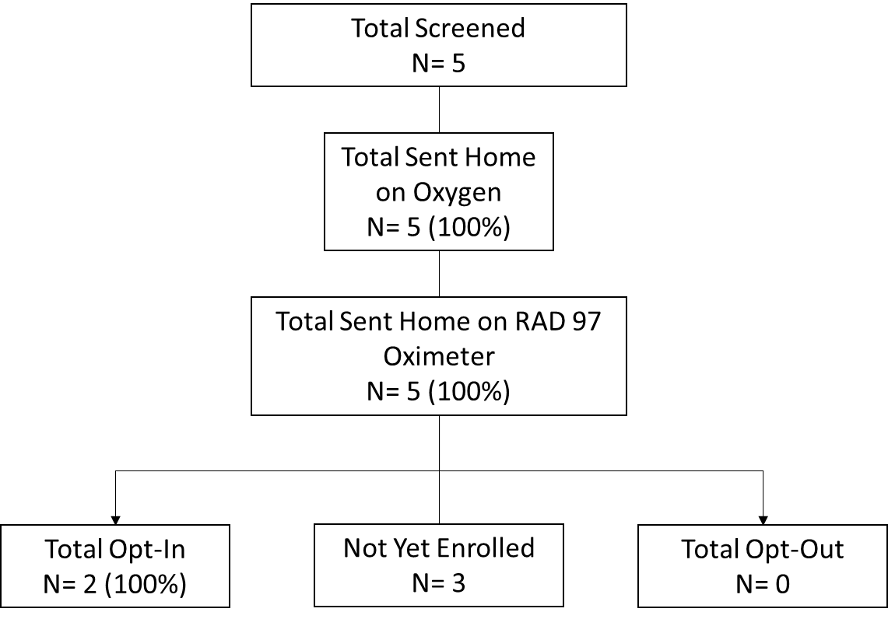
RHO Patient Education
- Prior to discharge families should be educated on the RHO Program. Families’ expectations of duration of HOT should be based on current literature using the RHO Trial’s average duration for intervention arm (RHO) infants.
  - We hope to learn from this project how to accurately answer the question ‘how long will my child be on oxygen’ after this project. Where more babies on different flow rates, illness severity, backgrounds etc. will be followed.
  - Data from UMass found the following characteristics predictive of longer durations (N=28)
    - higher flow rates initial flow rate at discharge
    - lower birth gestational age
    - SGA at birth
    - diagnosed with severe BPD
    - Co-sleeping or bed sharing once discharged from the NICU
  - At UMass, we typically will respond to parents’ questions about duration vaguely. Stating that by using objective physiological data to wean it is up to the infant when they are ready. And that the oxygen weaning process is not always a stepdown process, that increases are common and that their child, if they require an increase are still playing by the playbook.
- The Parent Brochure can be used as a resource and is available on the website.
The RHO Bi-Weekly Reports and Providing Feedback to Parents
- Since BCH and MGH have implemented, the question has been raised of how to properly reiterate and council families on the data.

  - At UMass, we typically do not provide the families with the actual time spent below each threshold and avoid the nitty gritty details of the data.
  - Dr. Cathy Shiels also recommends that we trust the data when speaking with families and follow the algorithm. As well as avoiding the details of the data but provide the overall recommendation.
  - This also helps keep communication time shorter.
- Families have raised the question that the oximeter is not alarming and that they are not seeing what the oximetry data is suggesting.
  - It is possible that some artifact may occasionally creep into the report, however, not to the point where it would impact the recommendation.
    - Heather is working with Masimo engineers to see if any optimization to our analysis program is possible to better eliminate artifact.
    - Alarm parameters are often set to alarm below 90% SpO2, while our algorithm considers anything below 93% SpO2 towards the recommendation of an increase. Therefore, anytime the child is spending between 90-93% the oximeter is not alarming but contributing to the total time spent below 93%.

Next Investigator Meeting will be on September 2nd at 4pm EST

Implementation Wave | Site # | Site Name | Contract Executed | cIRB Approval | Local IRB Approval | Regulatory Documents | pSite Communication Plan Agreement | REDCap Access | Site Training Completed | Site Implementation Date | First Enrollment Date | Downloading Schedule
Wave 1 | 102 | Boston Children's Hospital | ᴏ | ᴏ | ᴏ | ᴏ | ᴏ | ᴏ | ᴏ | 6/1/2021 |  | M/T
 | 106 | Dartmouth-Hitchcock | ᴏ | ᴏ | ᴏ | ᴏ | ᴏ | ᴏ | ᴏ | 6/1/2021 |  | T/F
 | 107 | Maria Fareri Children's | ᴏ | N/A | ᴏ | ᴏ | N/A | ᴏ | ᴏ | 6/1/2021 |  | M/T
 | 108 | Massachusetts General Hospital | ᴏ | ᴏ | ᴏ | ᴏ | ᴏ | ᴏ | ᴏ | 6/1/2021 |  | M/T
 | 113 | University of Maryland | ᴏ | ᴏ | ᴏ | ᴏ | ᴏ | ᴏ | ᴏ | 6/1/2021 |  | M/T
 | 114 | Vanderbilt | ᴏ | N/A | ᴏ | ᴏ | N/A | ᴏ | ᴏ | 6/1/2021 |  | T/F
Wave 2 | 101 | Arkansas Children's Hospital | ᴏ | ᴏ | ᴏ | ᴏ | ᴏ | ᴏ | ᴏ | 8/1/2021 |  | TBD
 | 103 | Children's Hospital of Phil. | ᴏ | ᴏ | ᴏ | ᴏ | ᴏ | ᴏ | ᴏ | 8/1/2021 |  | TBD
 | 104 | Cincinnati Children's Hospital | ᴏ | ᴏ | ᴏ | ᴏ | ᴏ | ᴏ | ᴏ | 8/1/2021 |  | TBD
 | 105 | National Jewish Health | ᴏ | ᴏ | ᴏ | ᴏ | ᴏ | ᴏ | ᴏ | 8/1/2021 |  | TBD
 | 109 | Nationwide Children's Hospital | ᴏ | ᴏ | ᴏ | ᴏ | ᴏ | ᴏ | ᴏ | 8/1/2021 |  | TBD
 | 110 | Peyton Manning Children's Hospital | ᴏ | ᴏ | ᴏ | ᴏ | ᴏ | ᴏ | ᴏ | 8/1/2021 |  | TBD
 | 111 | U. of California, San Diego | ᴏ | ᴏ | ᴏ | ᴏ | ᴏ | ᴏ | ᴏ | 8/1/2021 |  | TBD
 | 112 | U. of Kentucky Children's Hospital | ᴏ | ᴏ | ᴏ | ᴏ | ᴏ | ᴏ | ᴏ | 8/1/2021 |  | TBD

