September 2, 2021
4:00-5:00 PM EST
RHO Implementation Monthly Investigator Call Minutes
Invitees/Attendees:
Dr. Larry Rhein, Principal Investigator |  | Boston Children’s Hospital |  | Maria Fareri Children’s Hospital
Heather White, Project Coordinator |  | Children’s Hospital of Philadelphia |  | Massachusetts General Hospital
Lindsey Simoncini, Research Coordinator |  | Cincinnati Children’s Hospital |  | Nationwide Children’s Hospital
Maria Matoshi, Research Assistant |  | National Jewish Health, Colorado |  | Peyton Manning Children’s Hospital
Arkansas Children’s Hospital |  | Dartmouth-Hitchcock Medical Center |  | U. of California, San Diego
U. of Kentucky Children’s Hospital |  | University of Maryland |  | Vanderbilt

Site Trainings
- 12 out of 14 site trainings have been completed.
IRB/regulatory
- At this point contracts should be with your site’s office of sponsored programs.
- Due to SMART IRB approval delays our UMass IRB will be initiating site specific letters that should go out this week.
- If you haven’t decided on ceding approval or are having trouble, reach out to Heather for guidance.
- As the lead site we are required to have both Human Subject Research and Good Clinical Practice CITI Certificates for each member of your research team. Please send your certificates to Maria.
- Please let Heather know if you have completed a REDCap user request and have not been given an account. Larry must sign off on all user access request and we want to make sure there is no hold up.
Home Cares
- All sites have at least 2 home care companies supplying Rad 97s.
- Home care companies are placing special orders for Rad97s that are specifically configured to our SafetyNet.
- For the home care companies which already have non-configured Rad97s, Masimo is teaching them how to configure the devices.
  - For devices that become un-configured or were previously not configured home cares will have the ability to configure to the UMass SafetyNET without having to ship back to Masimo.
- We are working on a table that would demonstrate the quantity of configured Rad97s available at each home care company. Site specific breakdowns will be emailed out to each investigator once supplied by Masimo.
Site progress on Implementation Start-Up
- Refer to the Site Progress table on page 5.
- A total of 3 sites have started actively monitoring patients using the RHO program.
RHO Implementation Trial Consort Diagram
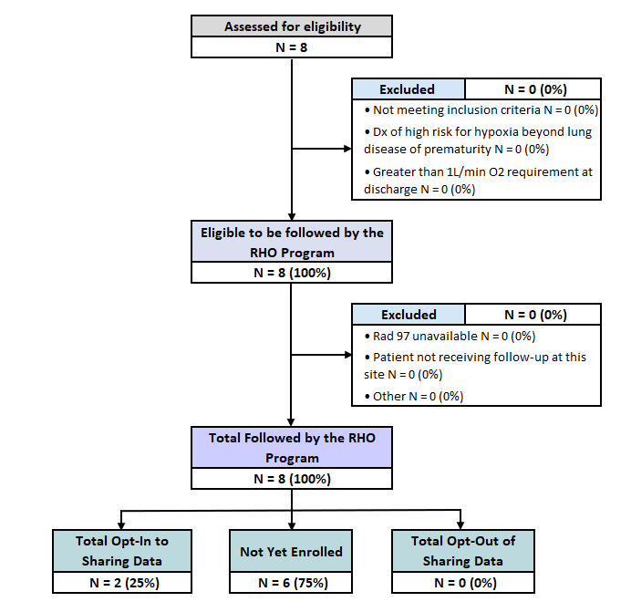
Screening and Eligibility
- We ask all sites to start screening infants going home on oxygen by completing the Screening and Eligibility form in REDCap.
- All infants deemed ineligible for the program should still have an ID number assigned in REDCap.
- We are in the process of updating the operational definition list regarding eligibility criteria.
- Any eligible infant can start being followed by the RHO program even if the site hasn’t officially started implementation. The Parent Brochure can be shared with families, the Fact Sheet cannot until IRB approval has been completed. Therefore, we won’t be actively tracking the infant’s data in REDCap forms.
- For screening and eligibility questions please email Heather and Maria.
Implementation Related Problems
- We are going to actively track the problems that arise while the RHO program is being implemented at each site.
- Our goal is to assess characteristics of the population for which the RHO program works best.
- We would like to express our gratitude to the sites that have already implemented the program and are helping us learn how to guide future implementation at other sites.
- Every site has been assigned a unique one letter identifier that Maria shared with each site over email. These unique one letter identifiers will be used in a web diagram that systematically categorizes implementation related problems.
- Some of the current problems that were faced by implementing sites are:
  - Home care company supplying a non-configured device.
  - Family not having access to wi-fi without prior knowledge by NICU staff.
  - PI Communication: please notify Heather and Maria once the oximeter is delivered to the patient (email template is provided in this month’s investigator meeting slides).
    - We need to know the patient’s RHO ID and a 10-digit oximeter (RAD 97) serial number to be able to admit the patient into our SafetyNet and obtain data.
    - If your home care company can only bring the equipment on the day of discharge please try to email us the same day.
    - For weekend discharges, the oximeter will be entered on Monday morning and data will be available at the next set data downloading day for your site.
THE RHO Program Website
- Please refer to our website for all the most recent documents. It is the most reliable and up-to-date source for any RHO Implementation related documentation.
- The investigator meeting slides and minutes are included on the website as well for your convenience.
Navigate to “Member Login” and log in with the following credentials to access the documents
  - Username: RHO
  - Password: Oximetry14
New Training Materials
- Heather is working on the Rad97 Troubleshooting Guide and an additional document with commonly asked questions to help manage families’ expectations regarding weaning off HOT.
- We will be adding additional clarification to the operational definitions for REDCap variables.
Next Investigator Meeting will be on October 7th at 4pm EST

Implementation Wave | Site # | Site Name | Contract Executed | cIRB Approval | Local IRB Approval | Regulatory Documents | pSite Communication Plan Agreement | REDCap Access | Site Training Completed | Site Implementation Date | First Enrollment Date | Downloading Schedule
Wave 1 | 102 | Boston Children's Hospital | ᴏ | ᴏ | ᴏ | ᴏ | ᴏ | ᴏ | ᴏ | 6/1/2021 |  | M/T
 | 106 | Dartmouth-Hitchcock | ᴏ | ᴏ | ᴏ | ᴏ | ᴏ | ᴏ | ᴏ | 6/1/2021 |  | T/F
 | 107 | Maria Fareri Children's | ᴏ | N/A | ᴏ | ᴏ | N/A | ᴏ | ᴏ | 6/1/2021 |  | M/T
 | 108 | Massachusetts General Hospital | ᴏ | ᴏ | ᴏ | ᴏ | ᴏ | ᴏ | ᴏ | 6/1/2021 |  | M/T
 | 113 | University of Maryland | ᴏ | ᴏ | ᴏ | ᴏ | ᴏ | ᴏ | ᴏ | 6/1/2021 |  | M/T
 | 114 | Vanderbilt | ᴏ | N/A | ᴏ | ᴏ | N/A | ᴏ | ᴏ | 6/1/2021 |  | T/F
Wave 2 | 101 | Arkansas Children's Hospital | ᴏ | ᴏ | ᴏ | ᴏ | ᴏ | ᴏ | ᴏ | 8/1/2021 |  | TBD
 | 103 | Children's Hospital of Phil. | ᴏ | ᴏ | ᴏ | ᴏ | ᴏ | ᴏ | ᴏ | 8/1/2021 |  | TBD
 | 104 | Cincinnati Children's Hospital | ᴏ | ᴏ | ᴏ | ᴏ | ᴏ | ᴏ | ᴏ | 8/1/2021 |  | TBD
 | 105 | National Jewish Health | ᴏ | ᴏ | ᴏ | ᴏ | ᴏ | ᴏ | ᴏ | 8/1/2021 |  | TBD
 | 109 | Nationwide Children's Hospital | ᴏ | ᴏ | ᴏ | ᴏ | ᴏ | ᴏ | ᴏ | 8/1/2021 |  | TBD
 | 110 | Peyton Manning Children's Hospital | ᴏ | ᴏ | ᴏ | ᴏ | ᴏ | ᴏ | ᴏ | 8/1/2021 |  | TBD
 | 111 | U. of California, San Diego | ᴏ | ᴏ | ᴏ | ᴏ | ᴏ | ᴏ | ᴏ | 8/1/2021 |  | TBD
 | 112 | U. of Kentucky Children's Hospital | ᴏ | ᴏ | ᴏ | ᴏ | ᴏ | ᴏ | ᴏ | 8/1/2021 |  | TBD

