Steps for starting a Medical Education Research project

General principles
- Start with a small, achievable project/intervention
- Do you prep work before approaching a mentor
- Think about what you are asking from a mentor (clinical input, teaching experience, research methods guidance, implementation support, etc)
- Try to minimize the work that a mentor needs to do – take ownership of your project
- Think about funding possibilities
- Think about goals for final product from this study (abstract, poster, manuscript)
- Think about next steps after this study

Getting Started
- Identify a topic of interest
- Perform a literature review
  - MedEd Portal
    - Great place to start for info regarding what is published in medical education
  - Scopus
    - Login through library webpage - https://library.umassmed.edu/
    - Use the "List" feature to build a library of papers on a specific topic
    - Tutorial for general search - https://www.youtube.com/watch?v=-VE3ADZvoUY&feature=emb_title
    - Tutorial for saving a search and setting alerts for new publications - https://www.youtube.com/watch?time_continue=62&v=AxlEP7ow0B8&feature=emb_title
  - Make a table in Excel to summarize your literature review (if you have time!)
  - Think about how this topic has been studied in the past, what kind of studies, what exposures/outcomes
  - What are the gaps in the literature?
- Use a reference manager to keep build your library of relevant references along the way
  - Mendeley
    - Download and install on your desktop - https://www.mendeley.com/download-desktop-new/
    - Open application and select "Literature Search" on top left. Use search bar to search author name and title of interest. Select publication name and click "Save Reference" in the top right.
    - Within Word document, select "References" and then "Open Mendeley". This allows your references in Mendeley to be added as citations and works cited within Word.
    - Tutorials for Mendeley - http://www.resources.mendeley.com/Videos/
- Study Design
  - Define a study/research question
  - Determine study design
    - Consider the following:
      - QI/assessing an intervention
      - assessing reaction/satisfaction with a training program
      - assessing learning and long term behavioral impact
  - Consider evaluation via the Kirkpatrick model for assessment of instituting a training
    - The Kirkpatrick Model is probably the best known model for analyzing and evaluating the results of training and educational programs
    - It takes into account any style of training, both informal or formal, to determine aptitude based on four levels criteria.
    - Examples: pre/post survey feedback about a learning/training intervention, how residents incorporate this training into dail practice, etc.
  - https://educationaltechnology.net/kirkpatrick-model-four-levels-learning-evaluation/
- Determine data collection plan
  - RedCap is great for any study that uses a survey or chart review
  - Tutorial videos - https://projectredcap.org/resources/videos/
  - To get the rights to initiate a project/design and build a database, you have to attend an one hour long, one-on-one training with a redcap specialist to become a study coordinator. Email REDCap-Support@umassmed.edu to arrange this.
  - ​To get access to an existing RedCap database, complete this request form: https://arcsapps.umassmed.edu/redcap/surveys/?s=XNAEDNARPP
- CITI Training
  - https://www.citiprogram.org/index.cfm?pageID=14
  - The basic courses you need for Umass IRB are:
1. Conflict of Interest
2. GCP for Clinical Trials with Investigational Drugs and Biologics (ICH Focus)
3. Group 1. Biomedical Research Investigators and Key Research Personnel
- IRB
  - IRB website - https://www.umassmed.edu/ccts/irb/
  - Request eIRB account -https://www.umassmed.edu/ccts/irb/eirb2/access/
  - eIRBJob Aids - https://www.umassmed.edu/ccts/irb/eirb2/job-aids-ii/
  - Try to work on the IRB documents! It will help you think about your study critically and identify areas where you need more guidance from mentors.
- Analytical Plan
  - Important to determine your analysis plan prior to starting the study
  - Meet with Peds department statistician
- Look for funding opportunities
- Approach a mentor with as much of this preparation work complete as possible to demonstrate your commitment to this topic and show the thought you have given it.
  - Prioritize literature review, well-defined research question, ideas about study design, ideas about how you will collect data, ideas for funding (if needed)
  - Even better if you can show that you have started to work on the IRB

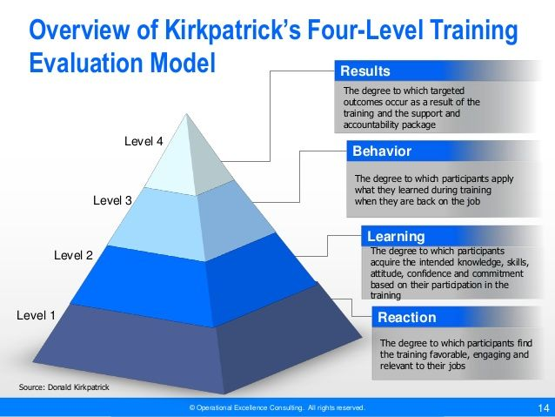
STROBE Statement—checklist of items that should be included in reports of observational studies

 |  | Item No | Recommendation
Title and abstract |  | 1 | (a) Indicate the study’s design with a commonly used term in the title or the abstract
 |  | 1 | (b) Provide in the abstract an informative and balanced summary of what was done and what was found
Introduction
Background/rationale |  | 2 | Explain the scientific background and rationale for the investigation being reported
Objectives |  | 3 | State specific objectives, including any prespecified hypotheses
Methods
Study design |  | 4 | Present key elements of study design early in the paper
Setting |  | 5 | Describe the setting, locations, and relevant dates, including periods of recruitment, exposure, follow-up, and data collection
Participants |  | 6 | (a) Cohort study—Give the eligibility criteria, and the sources and methods of selection of participants. Describe methods of follow-up  Case-control study—Give the eligibility criteria, and the sources and methods of case ascertainment and control selection. Give the rationale for the choice of cases and controls  Cross-sectional study—Give the eligibility criteria, and the sources and methods of selection of participants
 |  | 6 | (b) Cohort study—For matched studies, give matching criteria and number of exposed and unexposed  Case-control study—For matched studies, give matching criteria and the number of controls per case
Variables |  | 7 | Clearly define all outcomes, exposures, predictors, potential confounders, and effect modifiers. Give diagnostic criteria, if applicable
Data sources/ measurement |  | 8* | For each variable of interest, give sources of data and details of methods of assessment (measurement). Describe comparability of assessment methods if there is more than one group
Bias |  | 9 | Describe any efforts to address potential sources of bias
Study size |  | 10 | Explain how the study size was arrived at
Quantitative variables |  | 11 | Explain how quantitative variables were handled in the analyses. If applicable, describe which groupings were chosen and why
Statistical methods |  | 12 | (a) Describe all statistical methods, including those used to control for confounding
 |  | 12 | (b) Describe any methods used to examine subgroups and interactions
 |  | 12 | (c) Explain how missing data were addressed
 |  | 12 | (d) Cohort study—If applicable, explain how loss to follow-up was addressed  Case-control study—If applicable, explain how matching of cases and controls was addressed  Cross-sectional study—If applicable, describe analytical methods taking account of sampling strategy
 |  | 12 | (e) Describe any sensitivity analyses
Results
Participants | 13* | (a) Report numbers of individuals at each stage of study—eg numbers potentially eligible, examined for eligibility, confirmed eligible, included in the study, completing follow-up, and analysed
Participants | 13* | (b) Give reasons for non-participation at each stage
Participants | 13* | (c) Consider use of a flow diagram
Descriptive data | 14* | (a) Give characteristics of study participants (eg demographic, clinical, social) and information on exposures and potential confounders
Descriptive data | 14* | (b) Indicate number of participants with missing data for each variable of interest
Descriptive data | 14* | (c) Cohort study—Summarise follow-up time (eg, average and total amount)
Outcome data | 15* | Cohort study—Report numbers of outcome events or summary measures over time
Outcome data | 15* | Case-control study—Report numbers in each exposure category, or summary measures of exposure
Outcome data | 15* | Cross-sectional study—Report numbers of outcome events or summary measures
Main results | 16 | (a) Give unadjusted estimates and, if applicable, confounder-adjusted estimates and their precision (eg, 95% confidence interval). Make clear which confounders were adjusted for and why they were included
Main results | 16 | (b) Report category boundaries when continuous variables were categorized
Main results | 16 | (c) If relevant, consider translating estimates of relative risk into absolute risk for a meaningful time period
Other analyses | 17 | Report other analyses done—eg analyses of subgroups and interactions, and sensitivity analyses
Discussion
Key results | 18 | Summarise key results with reference to study objectives
Limitations | 19 | Discuss limitations of the study, taking into account sources of potential bias or imprecision. Discuss both direction and magnitude of any potential bias
Interpretation | 20 | Give a cautious overall interpretation of results considering objectives, limitations, multiplicity of analyses, results from similar studies, and other relevant evidence
Generalisability | 21 | Discuss the generalisability (external validity) of the study results
Other information
Funding | 22 | Give the source of funding and the role of the funders for the present study and, if applicable, for the original study on which the present article is based
*Give information separately for cases and controls in case-control studies and, if applicable, for exposed and unexposed groups in cohort and cross-sectional studies.

Note: An Explanation and Elaboration article discusses each checklist item and gives methodological background and published examples of transparent reporting. The STROBE checklist is best used in conjunction with this article (freely available on the Web sites of PLoS Medicine at http://www.plosmedicine.org/, Annals of Internal Medicine at http://www.annals.org/, and Epidemiology at http://www.epidem.com/). Information on the STROBE Initiative is available at www.strobe-statement.org.

