Ambulatory Blood Pressure Monitoring (IIf)
- Ambulatory blood pressure monitoring measures blood pressure values over a 24-hour period with measurements every 15-20 minutes during the day and 20-30 minutes during the night (Peterson 2017). This allows for the determination of mean systolic and diastolic blood values during the total 24-hour period, daytime hours, and nighttime hours. The goal blood pressure in ambulatory monitoring is <95th percentile as determined by the percentile charts in the AHA 2008 guidelines. Interpretation of the results include calculation of the blood pressure load, defined as the percent of blood pressure readings over the 95th percentile, with a goal load of <25% (Flynn 2014). The ambulatory monitoring will also allow you to see the nighttime dip, defined as the difference in blood pressure readings between the day and night, which should be ≥10% (Urbina 2008).
- Ambulatory blood pressure monitoring is suggested in pediatrics to confirm a diagnosis of hypertension, calculate the variability in blood pressure over a 24-hour period, determine the efficacy of drug treatment, and diagnose masked/white coat hypertension (Flynn 2014).

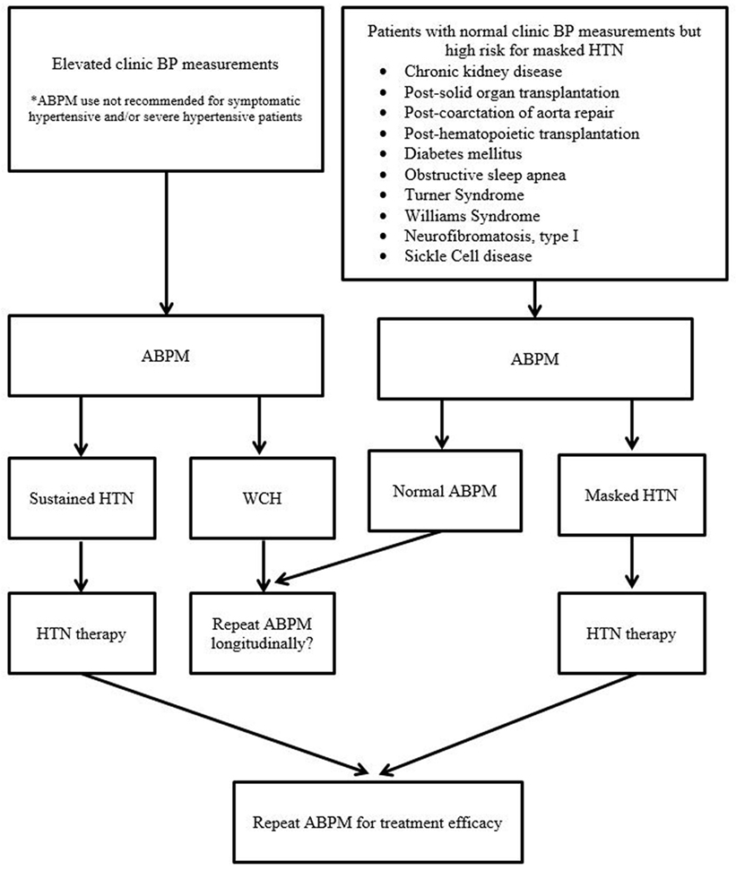
Peterson 2017

