Chronic Kidney Disease (Objective I.5, II.5)
- Chronic kidney disease is defined by the KDIGO guidelines according to the following table. Of note, age appropriate values should be considered for all pediatric patients, especially under the age of 2 (KDIGO 2012).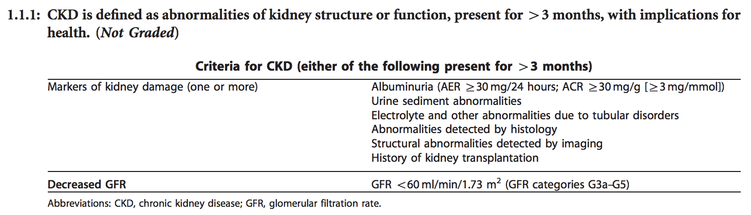
KDIGO 2012
- Chronic kidney disease is classified in children over the age of 2 according to the glomerular filtration rate as outlined in the table below. In children under the age of 2, GFR is classified according to age with values stratified as normal, moderately reduced, or severely reduced (KDIGO 2012).
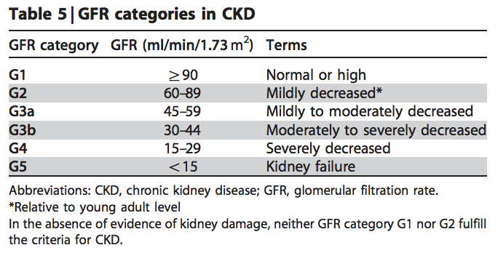
KDIGO 2012
Chronic kidney disease may also be classified according to the level of albuminuria according to the table below for children above the age of 2 (KDIGO 2012).
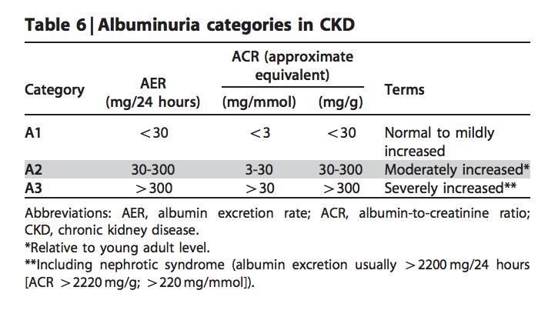
KDIGO 2012
- Assessment of chronic kidney disease should include a renal function panel, urinalysis for albuminuria, hematuria, pyuria, and electrolytes, renal ultrasonography, and serum electrolytes (KDIGO 2012).
- The management of chronic kidney disease is aimed at preventing the progression to end stage renal disease and treating complications including anemia, hypertension, vitamin D deficiency, acidosis, hyperphosphatemia, hypoalbuminemia, and hyperparathyroidism. Patients with end stage renal disease will ultimately require a renal transplant (KDIGO 2012). The following list is derived from the 2012 KDIGO, 2008 KDOQI, and Pediatrics in Review guidelines.
  - Hypertension: Blood pressure medication should be initiated with an ACE-I or ARB with readings persistently greater than the 90th percentile. The goal of treatment is a blood pressure reading under the 50th percentile (KDIGO 2012).
  - Growth impairment: All patients should have their growth closely monitored. Treatment of poor growth may consist of nutritional management or recombinant growth hormone (KDOQI 2009).
  - Nutrition/Diet: The diet should be optimized with the help of a nutritionist. Metabolic status including electrolytes and vitamins require close monitoring in these patients (KDOQI 2009).
    - Salt should be restricted in children with hypertension but may be supplemented in children with tubulopathies (KDIGO 2012).
    - Fluids should be increased in patients with polyuria and restricted in patients with oligoanuria (KDOQI 2009).
    - Protein intake should be targeted to 100-140% of the optimal requirements for body weight (KDOQI 2009).
    - Patients should consume 100% of daily requirements of thiamin, riboflavin, niacin, pantothenic acid, pyroxidine, biotin, cobalamin, ascorbic acid, retinol, a-tocopherol, vitamin K, folic acid, copper, and zinc. If dietary consumption is not adequate, these vitamins will need to be supplemented (KDOQI 2009).
    - Calcium consumption should be targeted to 100-200% of daily requirements (KDOQI 2009).
    - Vitamin D levels should be measured annually. Levels <30 ng/mL should be supplemented (KDOQI 2009).
    - Phosphorous intake should target 100% of daily requirements for patients with an elevated parathyroid and normal phosphorous. The target is reduced to 80% for patients with both an elevated parathyroid and phosphorous (KDOQI 2009).
    - Potassium should be limited in patients at risk for hyperkalemia (KDOQI 2009).
  - Diabetes: Management should be optimized according to the ADA guidelines (KDIGO 2012).
  - Life style: Patients should be encouraged to maintain a healthy weight and exercise for 30 minutes 5 days per weeks. Patients should be counseled on the risks of smoking (KDIGO 2012).
  - Anemia: Anemia in pediatric chronic kidney disease patients is defined as a hemoglobin of <11 between the ages of 6 months and 5 years, <11.5 between the ages of 5-12, and <12 between ages 12-15. Patients should be screened as needed with a GFR >60, annually with a GFR of 30-59, and biannually with a GFR of <30. Treatment may include iron replacement or erythropoietin stimulating agents (KDIGO 2012).
  - Acidosis: Patients are at risk of developing a metabolic acidosis. Treatment consist of sodium bicarbonate with a target serum level of >22 mEq/L (KDOQI 2009).
  - Hyperkalemia: Patients are at risk of developing hyperkalemia which should be promptly treated with a combination of sodium bicarbonate, calcium gluconate glucose, insulin, sodium polystyrene sulfonate and beta agonists (White and Fine 2020).
  - Secondary hyperparathyroidism/ Renal Osteodystrophy: Patients with chronic kidney disease may develop hyperphosphatemia, hypocalcemia, and vitamin D deficiency, resulting in secondary hyperparathyroidism. Vitamin D supplementation is required at CKD stage 3 until normal levels of parathyroid hormone and phosphorous are achieved. High phosphorous is treated with a phosphate binder (White and Fine 2020).

